**TASK – ROLES IN ANSIBLE**

**Step 1: Launch the EC2-Linux instance :**

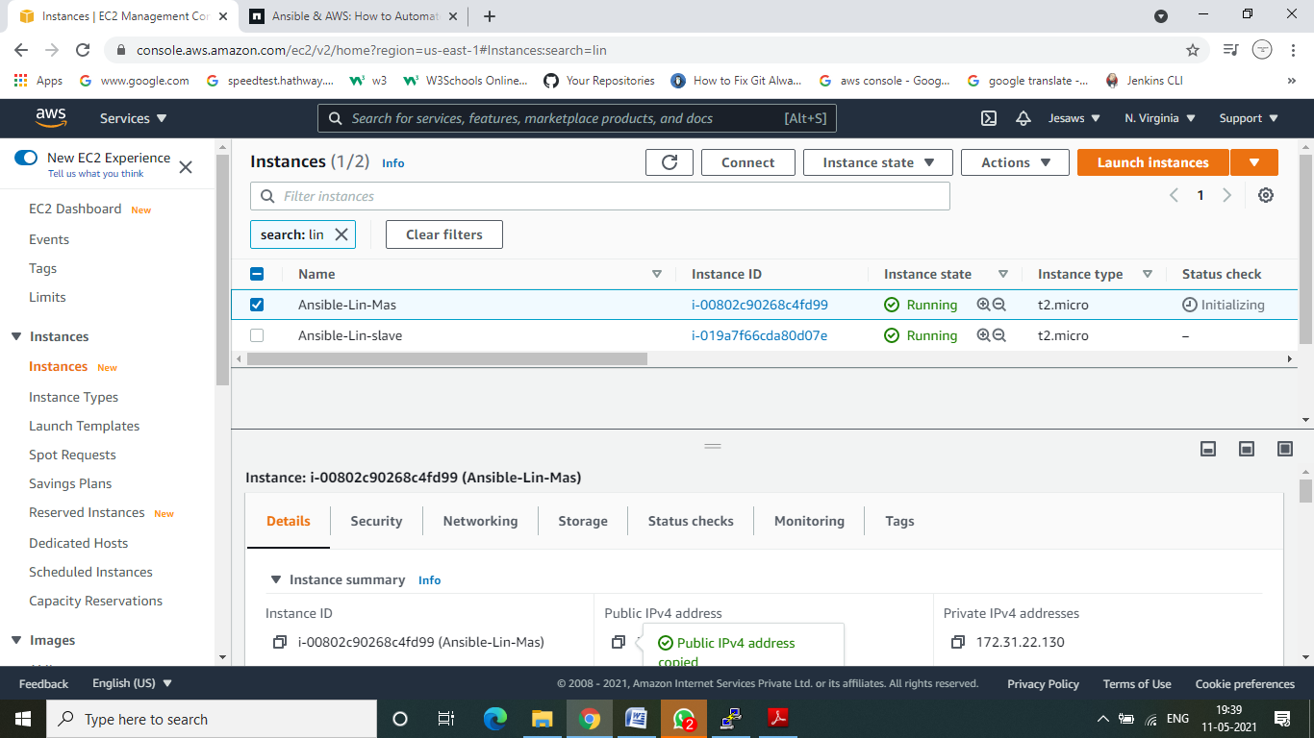

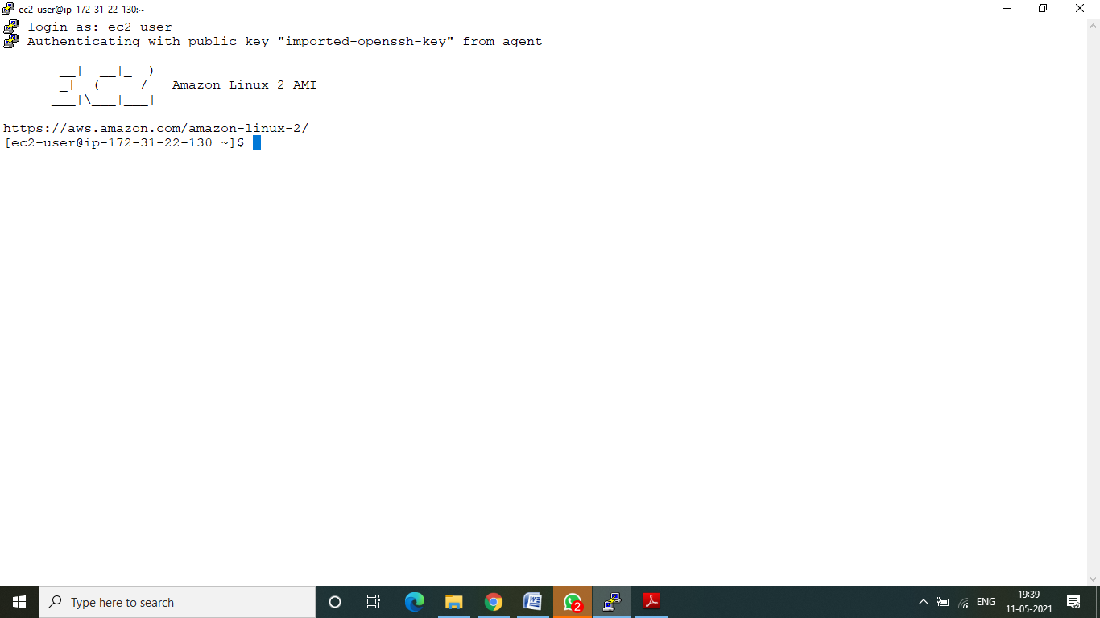

**3.Switch to root user**

**4. Update Server Packages**

yum update –y

**5. Install the ansible**

wget https://dl.fedoraproject.org/pub/epel/epel-release-latest-7.noarch.rpm

**Install epel repository**

yum install epel-release-latest-7.noarch.rpm

**Update epel repository**

yum update –y

**Install all individual packages inside the repository**

yum install git python python-devel python-pip openssl ansible –y

**Verify Version of Ansible**

ansible --version



